Name: Mahmood Ul Hassan
Roll NO: 24451
Subject: Software Construction
Lab NO: 5
Instructor: Ma’am Faryal Riaz

Task 1: Declare and Initialize an Array

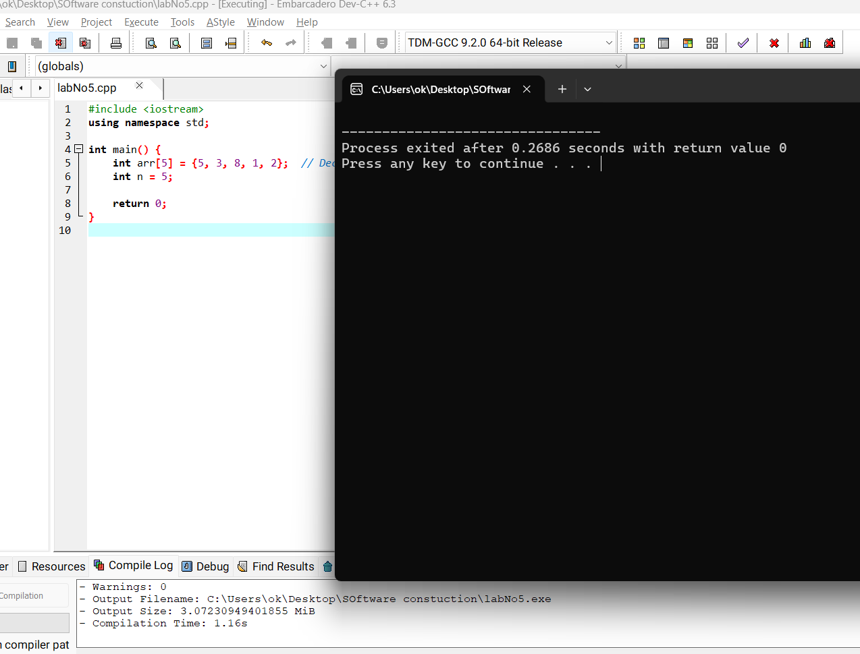
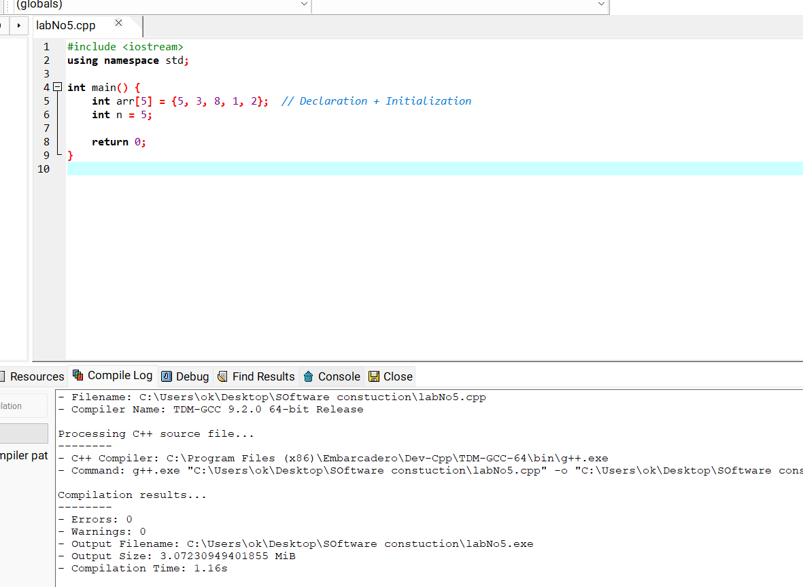

Task 2: Traverse the Array

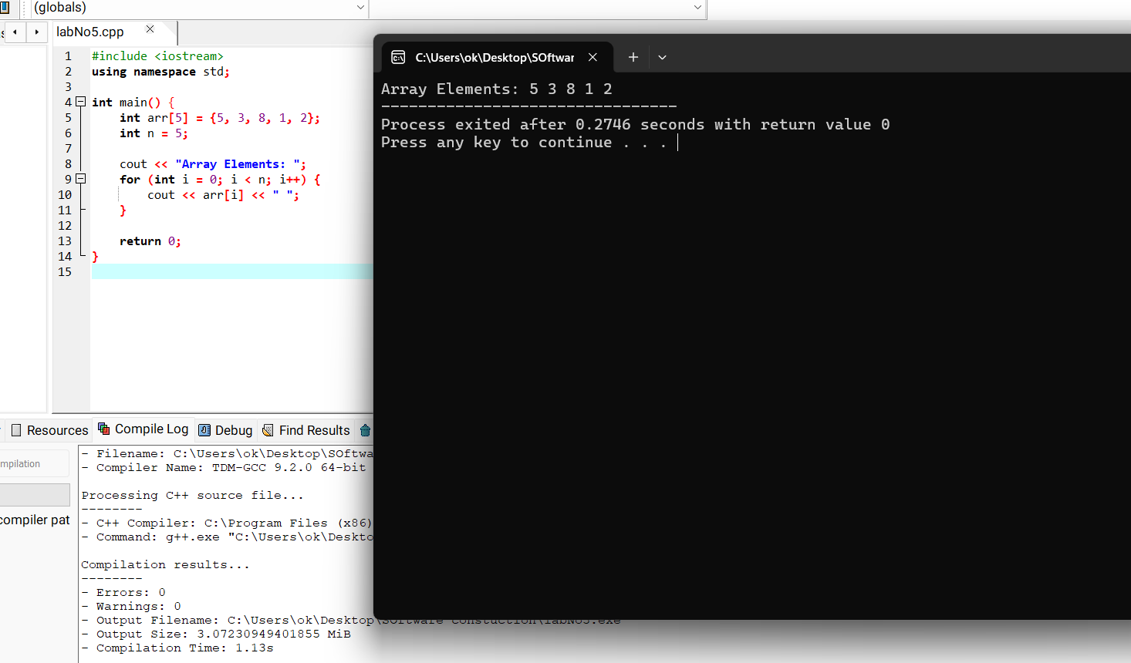
Task 3: Find Maximum and Minimum

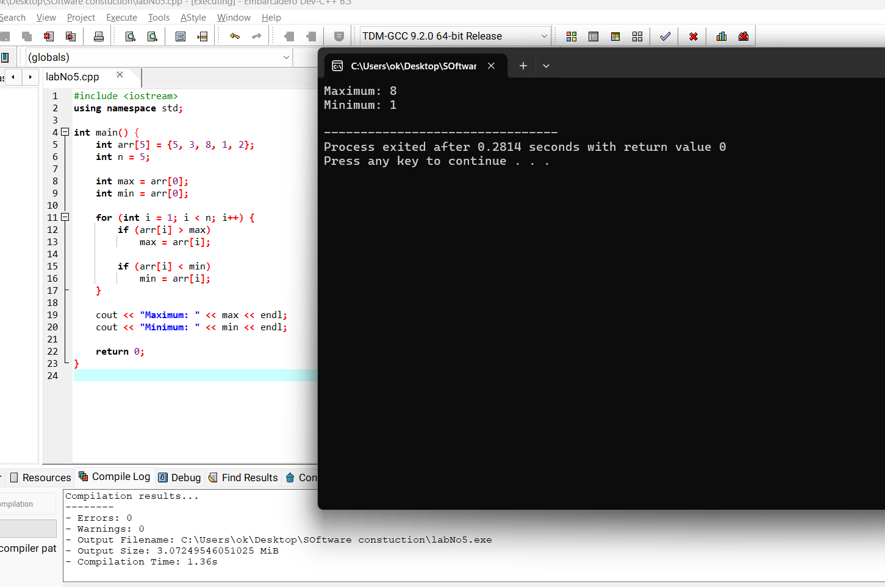

Task 4: Bubble Sort (Ascending Order)
